ESRI Comparison Tool - Help Documentation
This tool is designed to make it easier to compare Original ESRI assay data with Deep Learning (DL) imputed assay data. By following a guided workflow, you’ll upload your files, map your columns, run quick statistical checks, apply comparison methods, and finally export heatmaps or grid CSVs for further use.
The interface is organized into steps (1 to 6) at the top, and the sidebar on the left mirrors those steps: Data Loading → Data Analysis → Comparison → Export.
Let’s go through them one by one.

1. Data Loading
This is the first step you’ll see when opening the tool.

Uploading Files

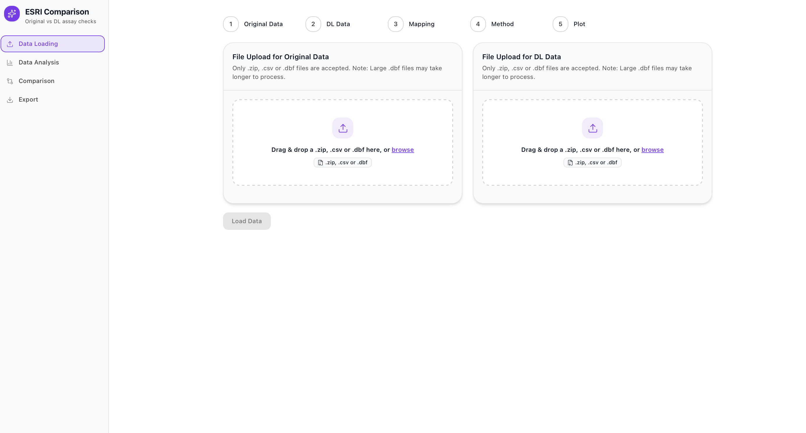
- On the left side, you’ll see Step 1: File Upload for Original ESRI Data.
- On the right side, you’ll see Step 2: File Upload for DL ESRI Data.
- Each box accepts either a .csv, a .zip file or a .dbf
  - If you upload a .zip, make sure it contains only one CSV or DBF at the top level.
  - The CSV must have coordinate columns (Northing/Easting or Latitude/Longitude) and an assay column (for example, Te_ppm).
You can drag & drop your file into the upload area or click browse to select it manually.

Loading Data

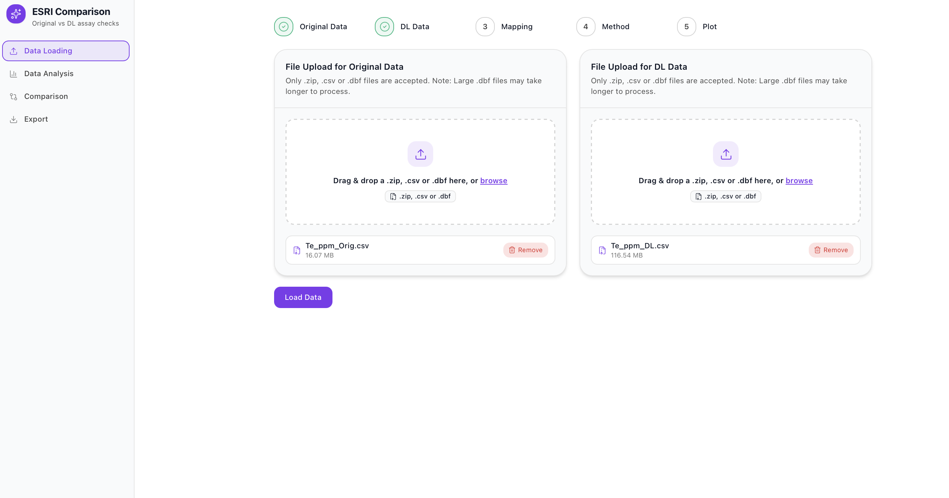
Once both files are uploaded, they will appear below the upload boxes with their names and sizes. You can remove them at any time by clicking Remove.
Click the Load Data button to process the files.
- You’ll see progress bars (purple for Original, orange for DL) as the files load.
- When successful, green checkmarks ✅ appear on the step indicators at the top.
- If loading fails, a popup message will appear (e.g., “Load failed”).
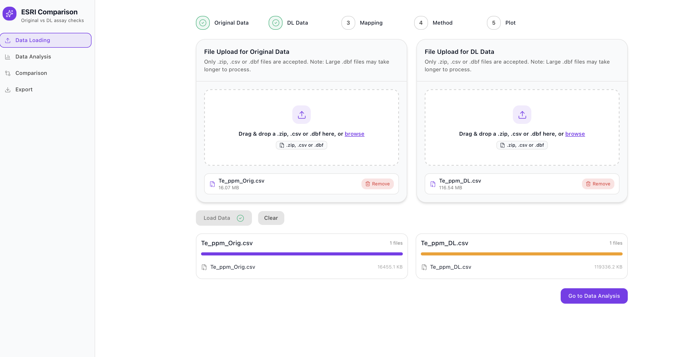

Troubleshooting:
- Check the file format: CSV must be UTF-8 encoded with consistent delimiters.
- Check the columns: Northing/Easting (or Lat/Long) and assay values must be present.
- If files are very large, compress them into .zip first.
Once data is loaded correctly, the Go to Data Analysis button will become active, allowing you to move to the next stage.

2. Data Analysis
Now that the data is loaded, the next step is to tell the tool which columns correspond to coordinates and assay values. This is called Mapping.
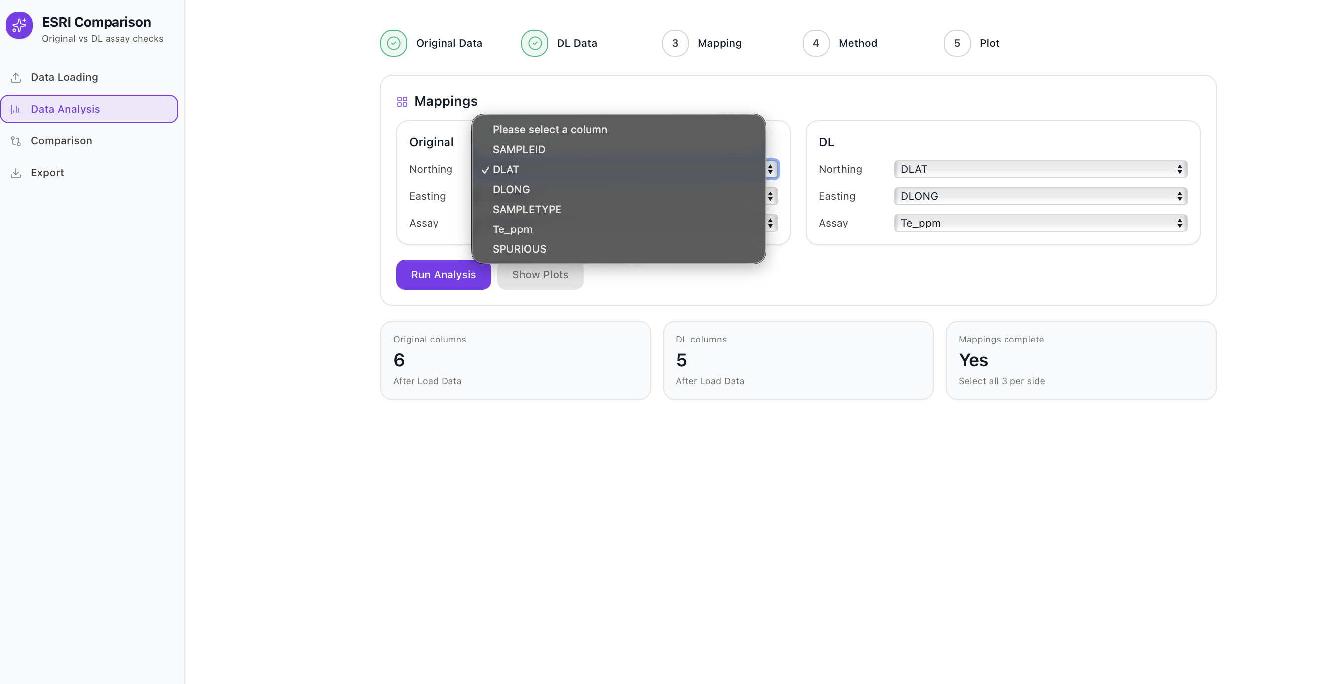
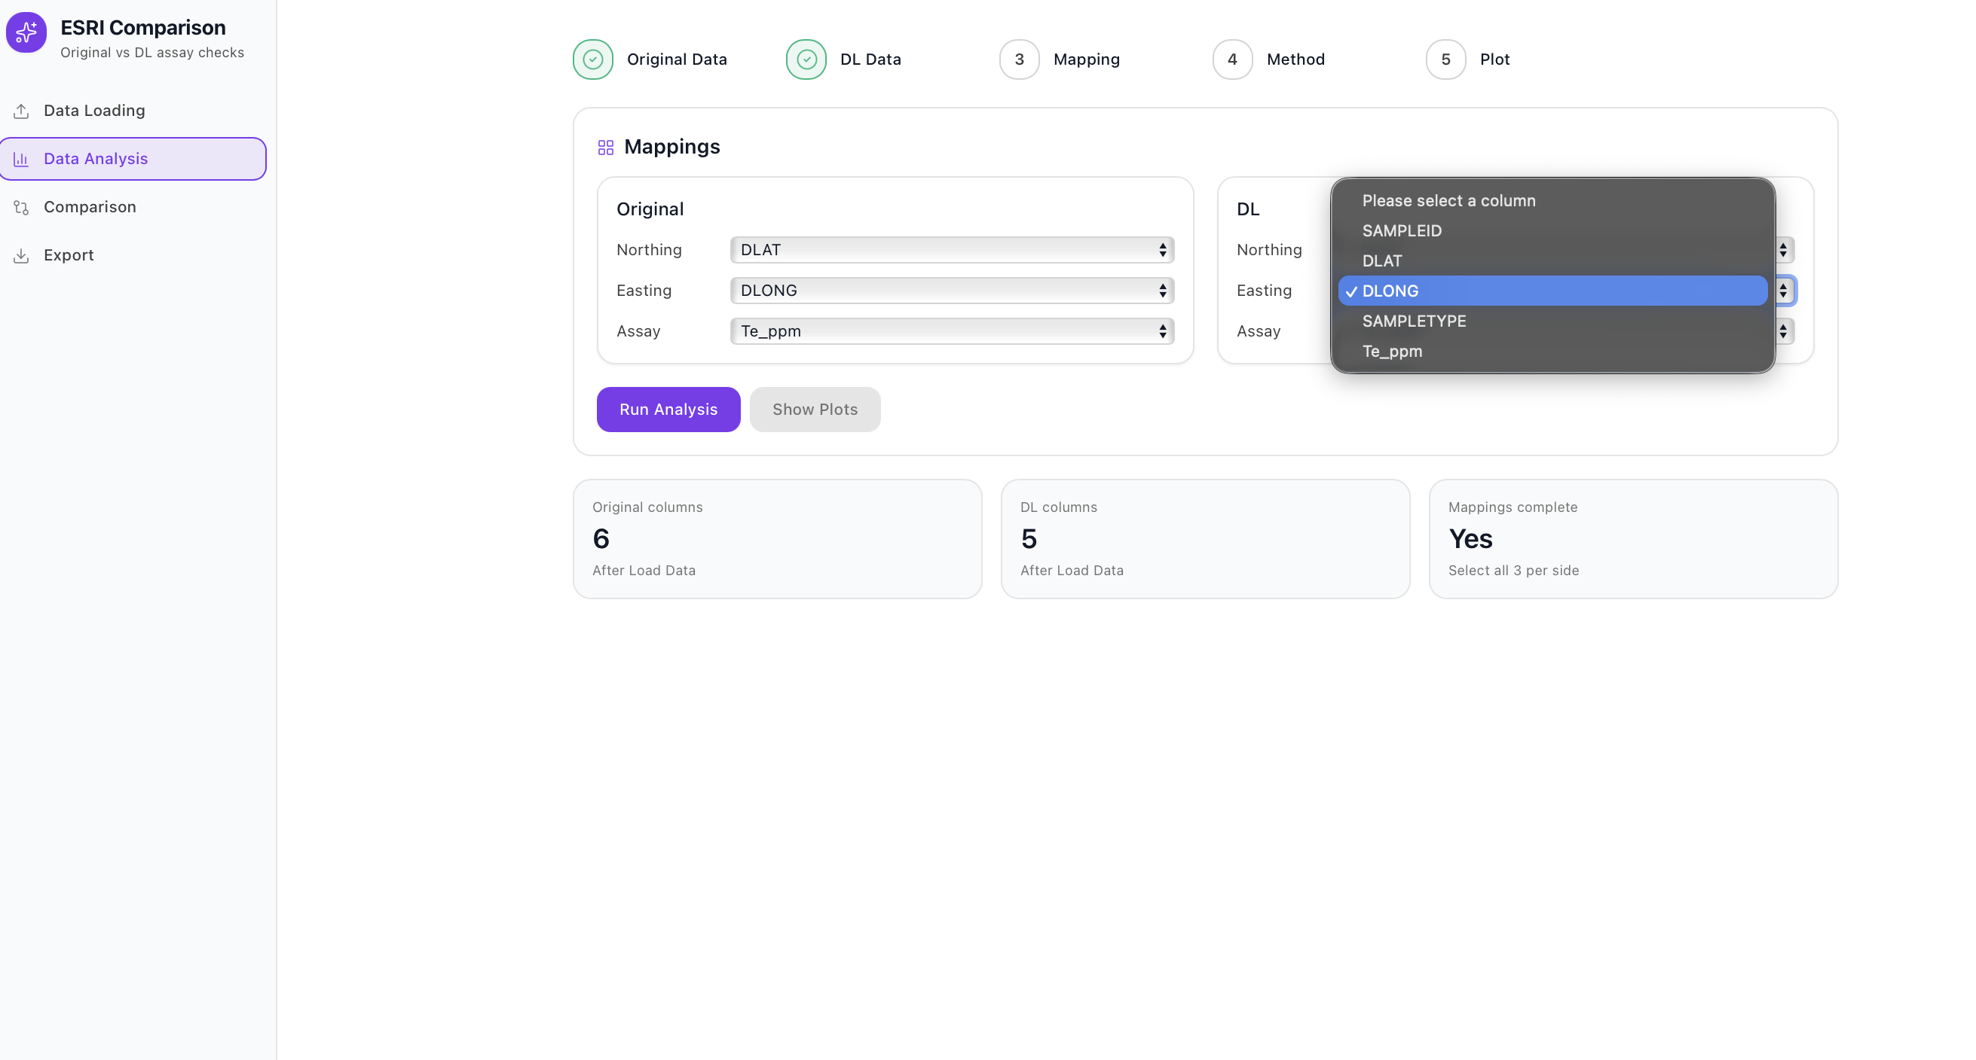

Column Mapping
For both the Original and DL datasets, you must map three things:
- Northing (Y coordinate)
- Easting (X coordinate)
- Assay (the element or variable being compared, e.g., Te_ppm)
Use the dropdown menus to select the right column names from your CSV.
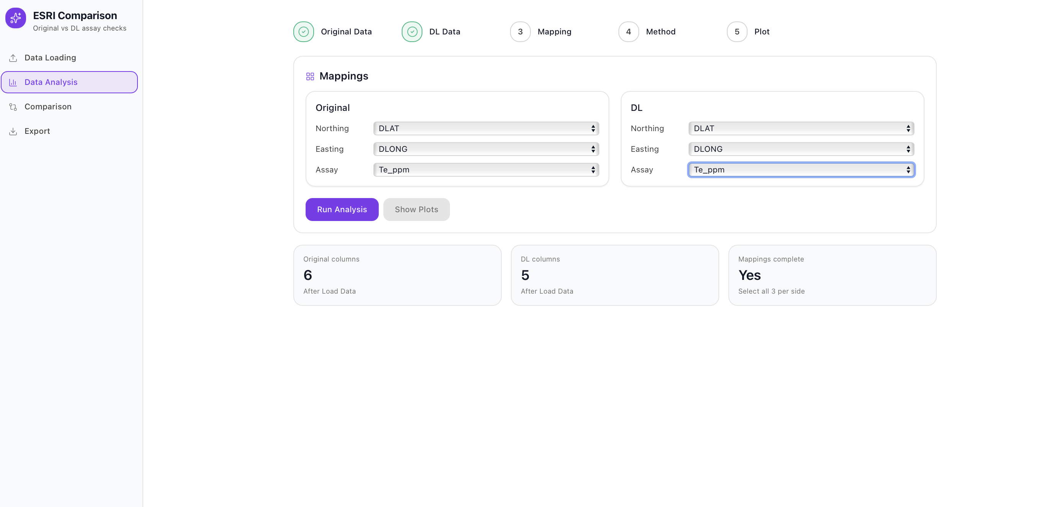
- Example: Northing → DLONG, Easting → DLAT, Assay → Te_ppm.
- Do this for both Original and DL.
At the bottom of the panel you’ll see a status indicator:
- “Mappings complete: No” means you haven’t finished mapping.
- Once all three fields are selected on both sides, it changes to “Mappings complete: Yes”.

Running Analysis

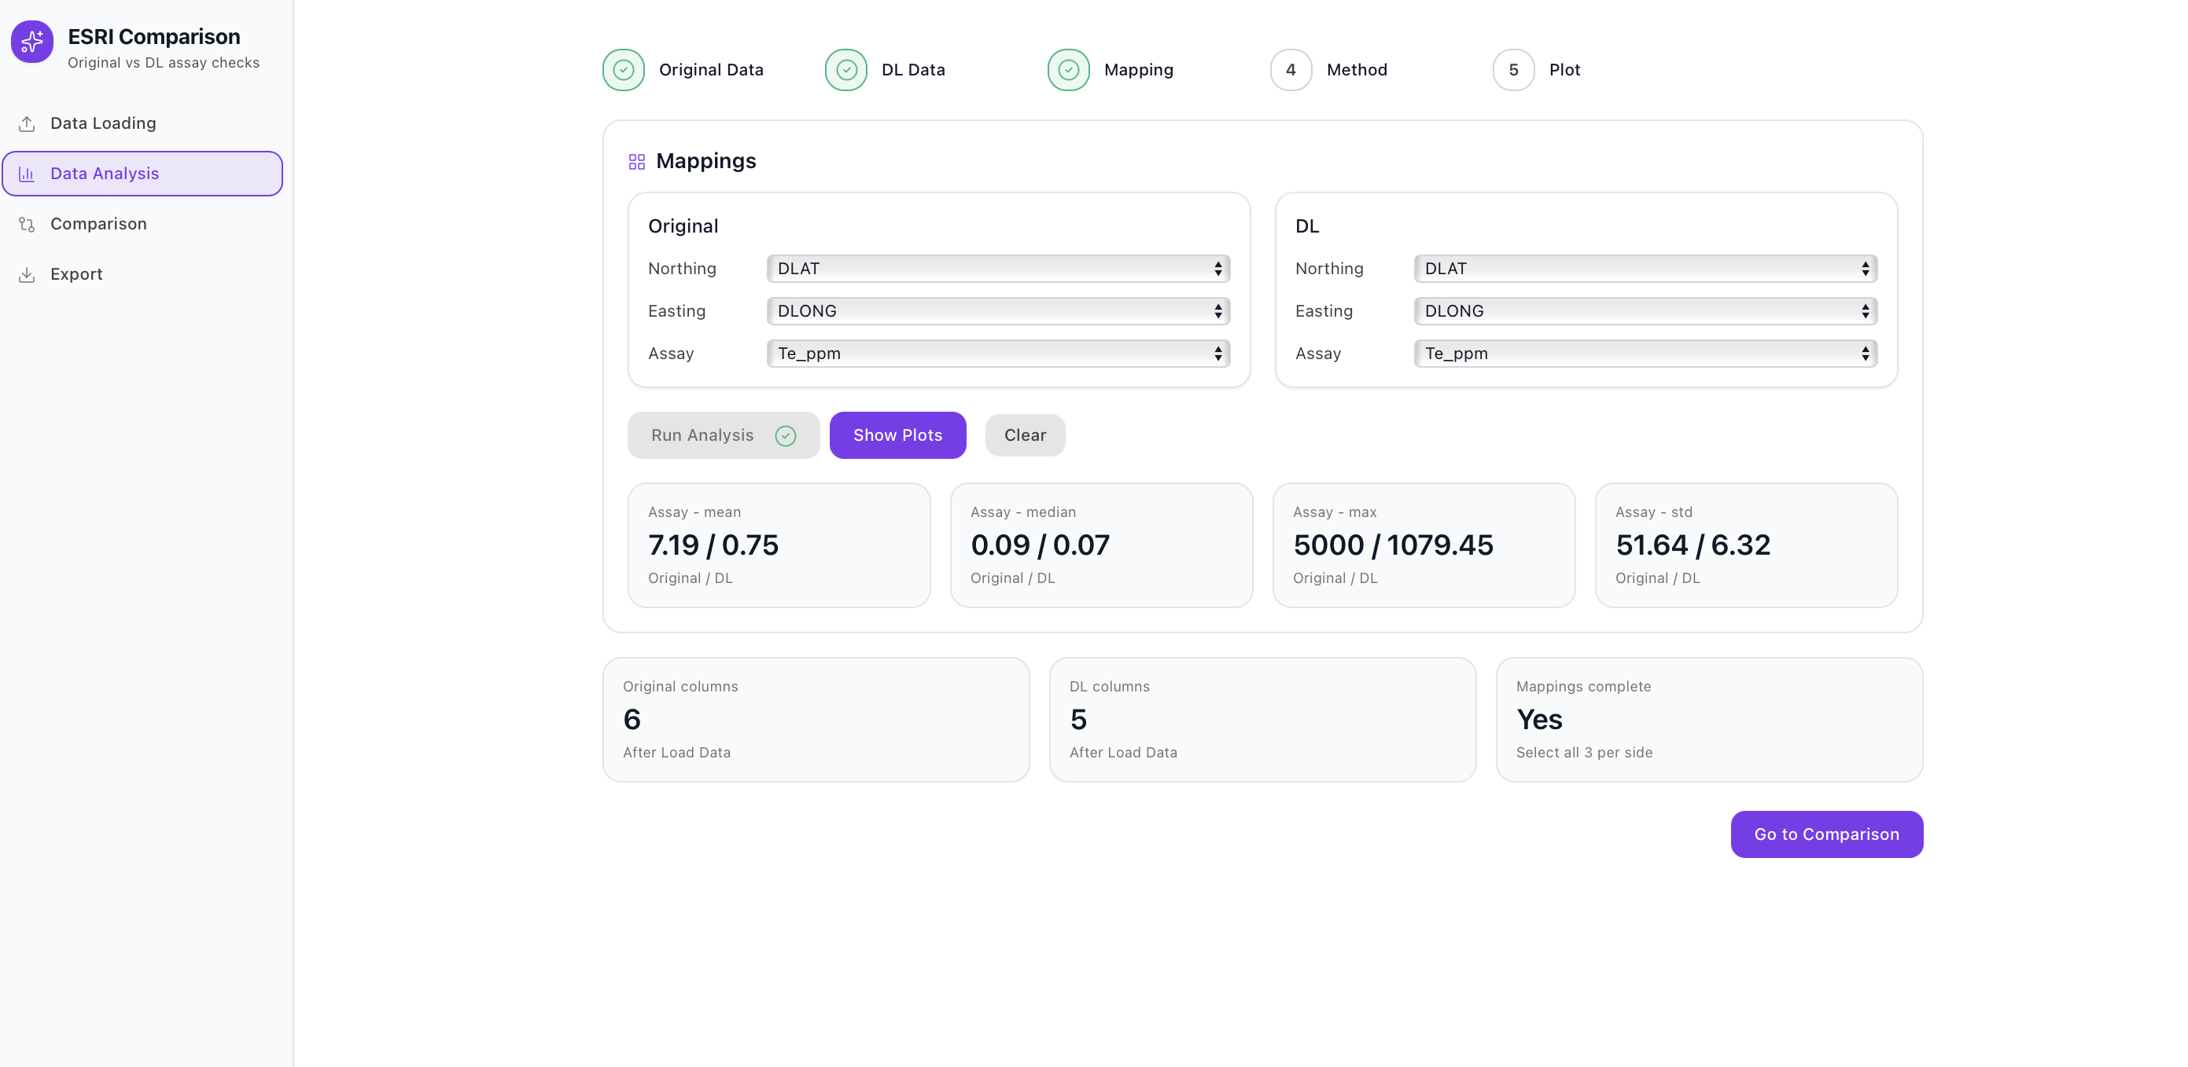
Click Run Analysis to calculate summary statistics for the two datasets. These appear just below the mapping area and include:
- Mean (average assay value)
- Median (middle value)
- Max (largest value)
- Std (standard deviation)
The values are displayed as Original / DL side by side, making it easy to see differences.

Viewing Plots

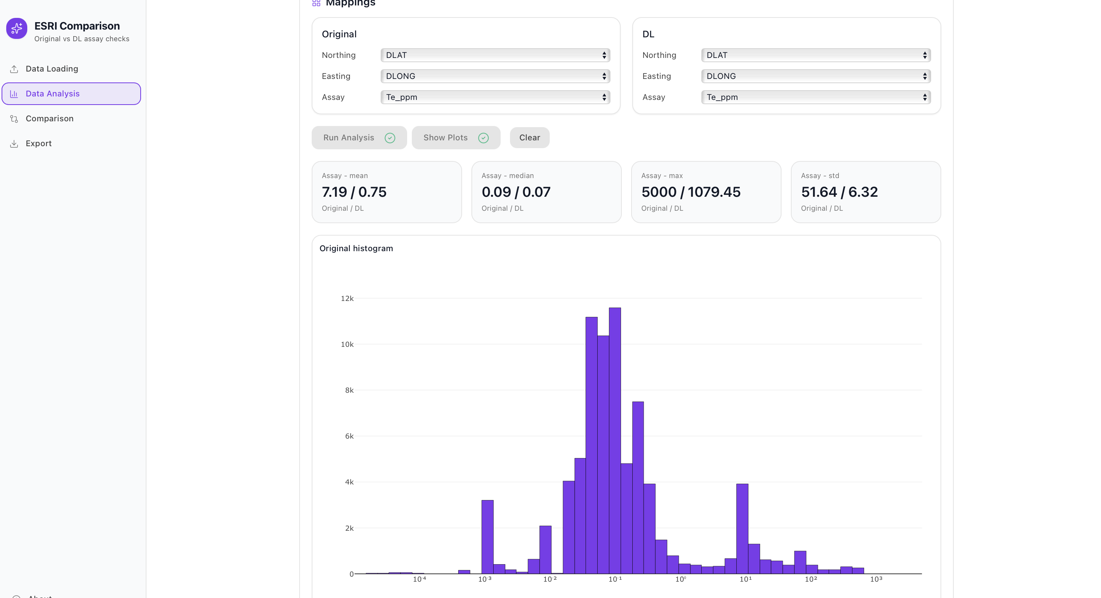

After running analysis, you can click Show Plots to view:
- Histogram of Original assay values
- Histogram of DL assay values
- QQ plot (log-log) comparing Original vs DL distributions
These plots are small previews. If you click one, it opens in a larger modal view for closer inspection.
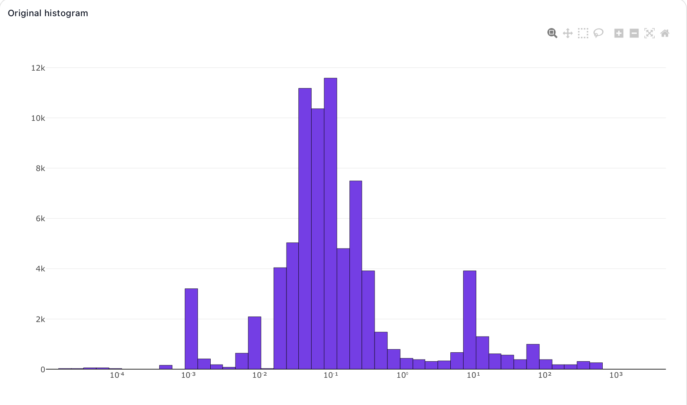
- Histograms help you check distributions.
- QQ plots help you check how closely the DL values align with the Original ones across quantiles.
Plotly controls overview
Control Name | Purpose | How to Use / Example
Zoom | Focus on a smaller area of the chart for closer inspection. | Click and drag a box around the region you want to zoom into. Double-click anywhere on the chart to return to the full view.
Pan | Move the visible area of the chart once zoomed in. | Select Pan, then click and drag to navigate around. Helpful for exploring different regions without changing the zoom level.
Box Select | Highlight all data points or bars within a rectangular area. | Click and drag to select part of the chart. Useful for examining dense clusters or specific Te_ppm ranges.
Lasso Select | Freehand selection of irregularly shaped clusters of points. | Draw around the points you wish to highlight. Ideal for identifying outliers or irregular data regions.
Zoom In | Gradually magnify the chart to see finer details. | Click once to zoom in toward the chart’s center. Perfect for making small incremental zoom adjustments.
Zoom Out | Step back to view a larger portion of the chart. | Click once to zoom out. Combine with Zoom In to fine-tune your data view.
Autoscale | Automatically rescale both axes to fit all visible data. | Click once to refit and center the entire dataset within the chart after zooming or panning.
Reset Axes | Restore the chart to its original default view. | Click the Reset Axes button or double-click anywhere on the plot to return to the initial, full Australia-wide view.
When satisfied, click Go to Comparison to proceed.

3. Comparison
Here you decide how to compare the datasets across a spatial grid.
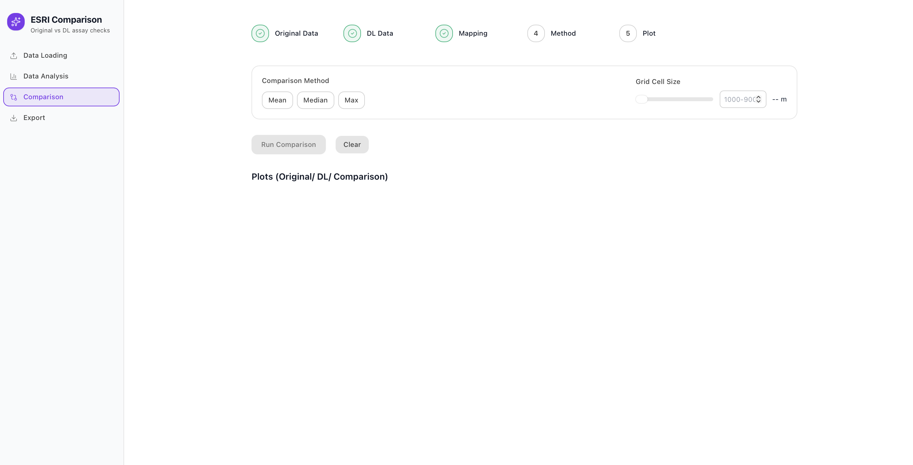

Comparison Methods

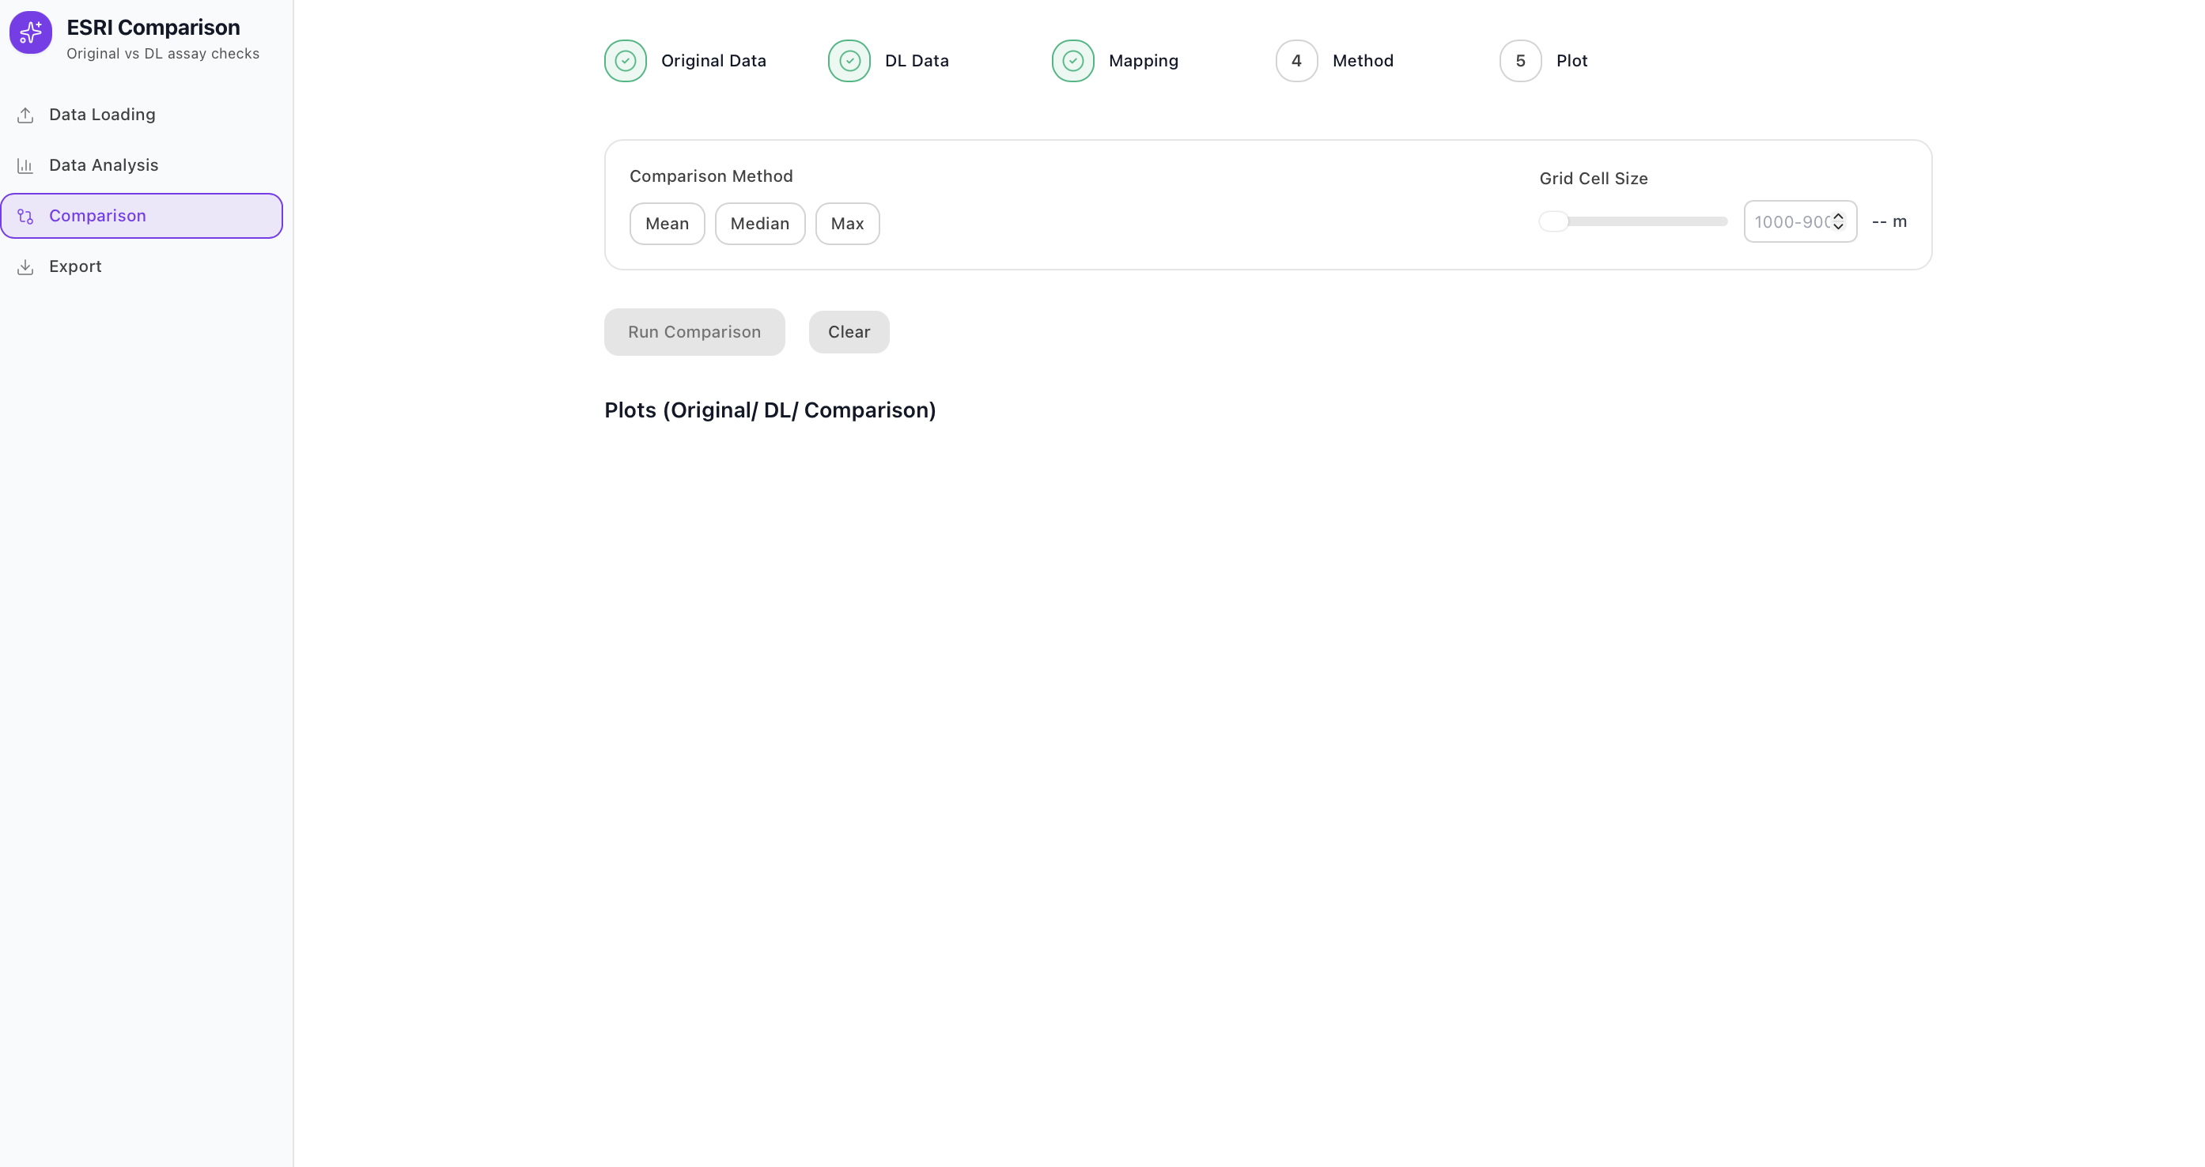
You’ll see method buttons:
Technique | Original graph | DL graph | Comparison graph
Mean | Mean | Mean | Difference
Median | Median | Median | Difference
Max | Max | Max | Difference
Chi2 | Count | Count | Chi2 value
P90 | P90 | P90 | Diff
Tail Ratio | Proportion | Proportion | Diff
EMD | Count | Count | EMD value

Mean
The mean comparison method calculates the average Tellurium concentration for each grid cell in both datasets and then computes the difference (DL − Original).
It provides a simple measure of overall bias - whether DL values tend to be higher or lower than the original data across each area.
Median
The median method compares the middle value of the Tellurium distribution within each grid cell.
Because the median is less sensitive to extreme outliers, this approach highlights systematic shifts while reducing the influence of a few anomalous samples.
Maximum (Max)
The maximum method takes the highest Tellurium value recorded in each grid cell and compares DL and Original datasets.
It emphasizes potential high-value zones and helps identify whether DL predictions capture the same peak concentrations observed in the original data.
Chi-Square (χ²)
The chi-square test compares the distribution shapes of Tellurium values between DL and Original datasets within each cell.
It measures how similar or different the two frequency distributions are, with higher χ² values indicating greater divergence in sample distributions.
90th Percentile (P90)
The P90 method evaluates the upper percentile (90th) of Tellurium concentrations in each cell.
It is useful for assessing whether the DL dataset reproduces the upper-end geochemical variability - for example, how well it captures high-grade anomalies without being dominated by outliers.
Tail Ratio
The tail ratio compares the relative proportion of high-value samples in DL versus Original data.
It focuses on the distribution’s upper tail (e.g., samples above a threshold such as the 90th percentile) and provides a simple indicator of how well DL data replicate extreme geochemical responses.
Earth Mover’s Distance (EMD)
The Earth Mover’s Distance quantifies the minimum “effort” required to transform one distribution into another by redistributing probability mass.
In this context, it measures how much the DL value distribution would need to “shift” to match the Original data within each grid cell. Lower EMD values indicate closer agreement between datasets.
Select the method that best fits your analysis needs.

Grid Cell Size

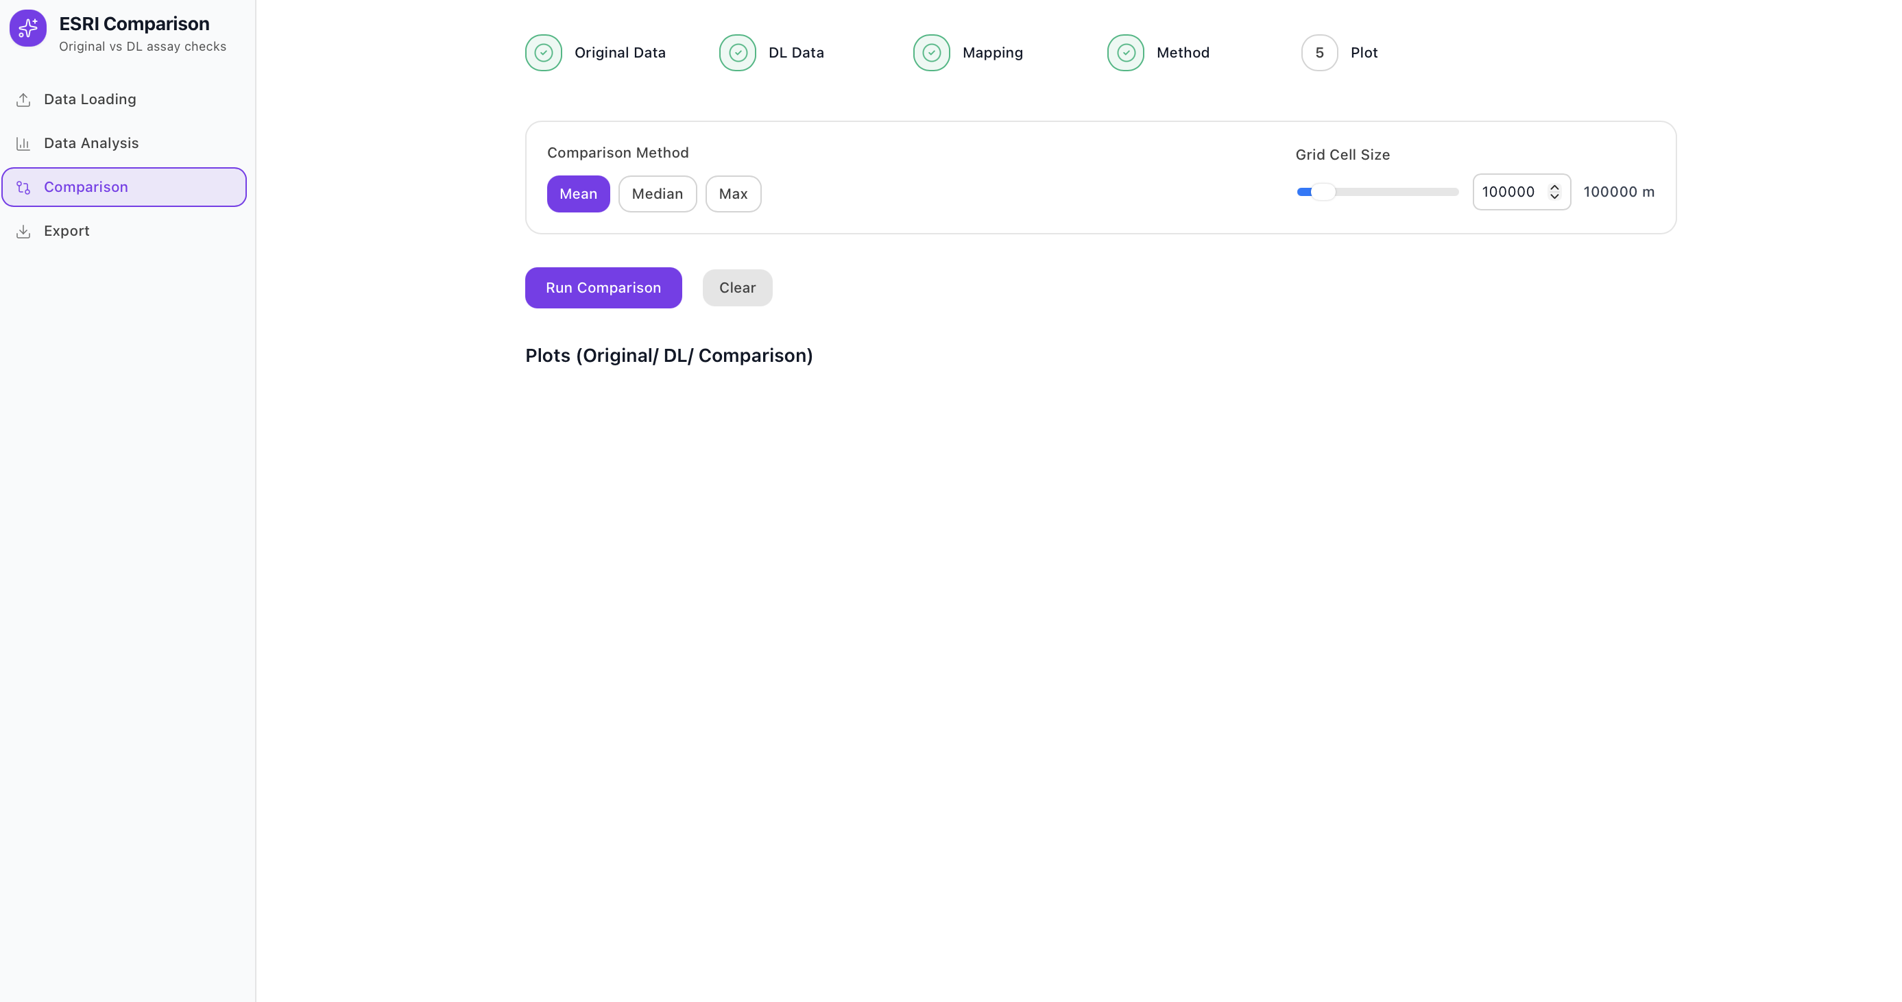
You’ll also see a slider and number box for choosing the grid cell size (in metres).
- Smaller cells (e.g., 100 m) → more detailed, but noisier.
- Larger cells (e.g., 1000 m) → smoother, better for sparse datasets.

Running the Comparison

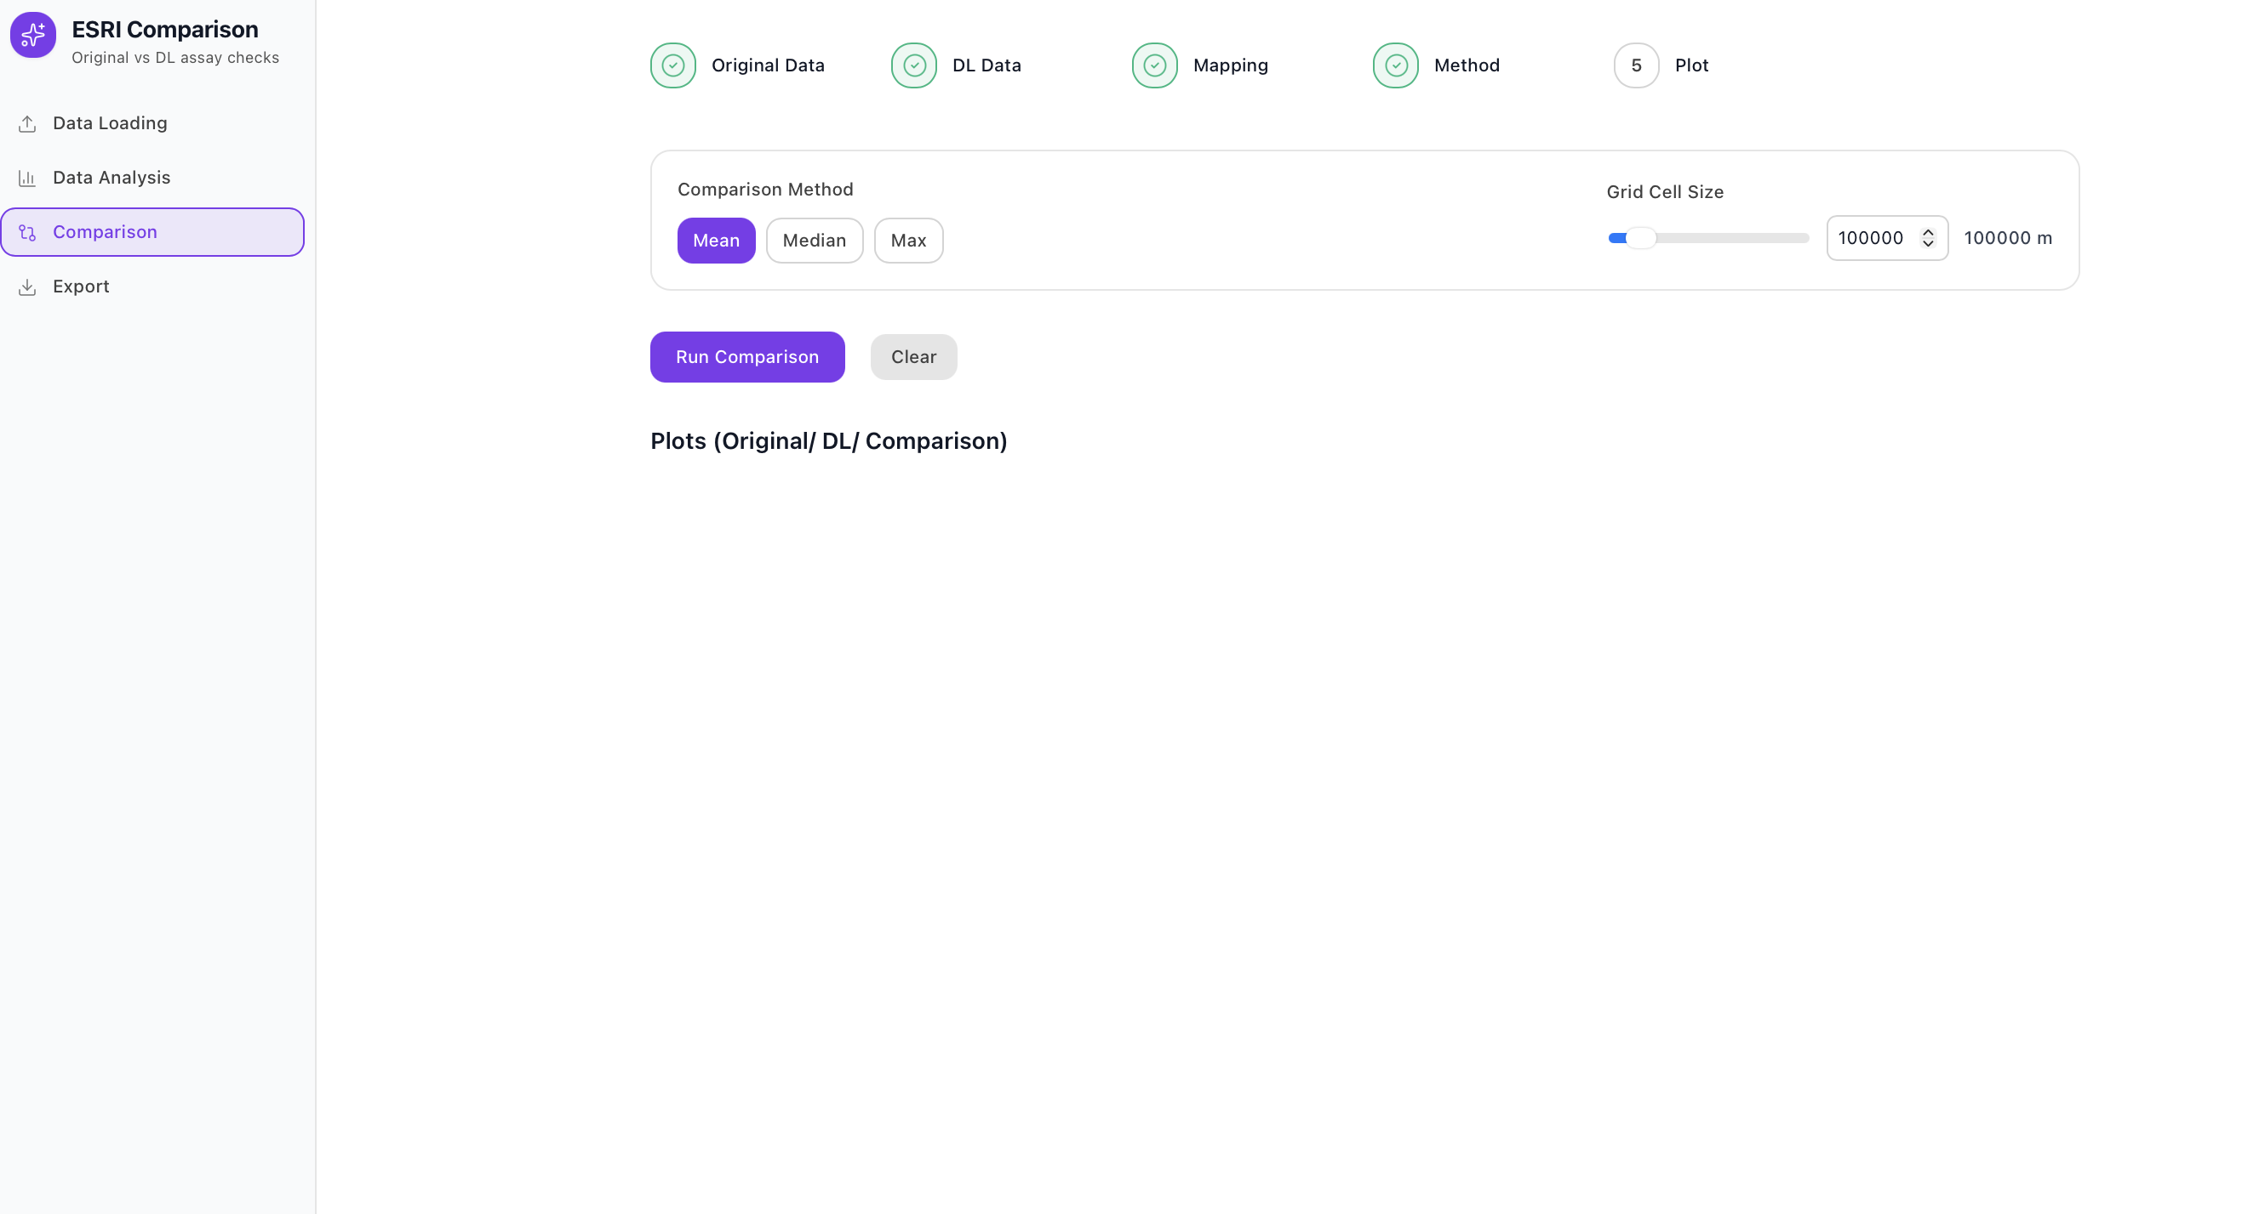

Once the method and grid size are chosen, click Run Comparison. Once initiated, the tool performs the following steps automatically:
- It divides the entire mapped area into grid cells based on your selected cell size.
- It computes the chosen statistic (Mean, Median, or Max) for both the Original and DL datasets within each cell.
- It calculates the difference (DL - Original) for each grid cell to show how DL values compare spatially with the Original dataset.
After processing, three heatmaps are displayed side by side:
- Original Heatmap - Shows the spatial distribution of Te_ppm values from the Original dataset.
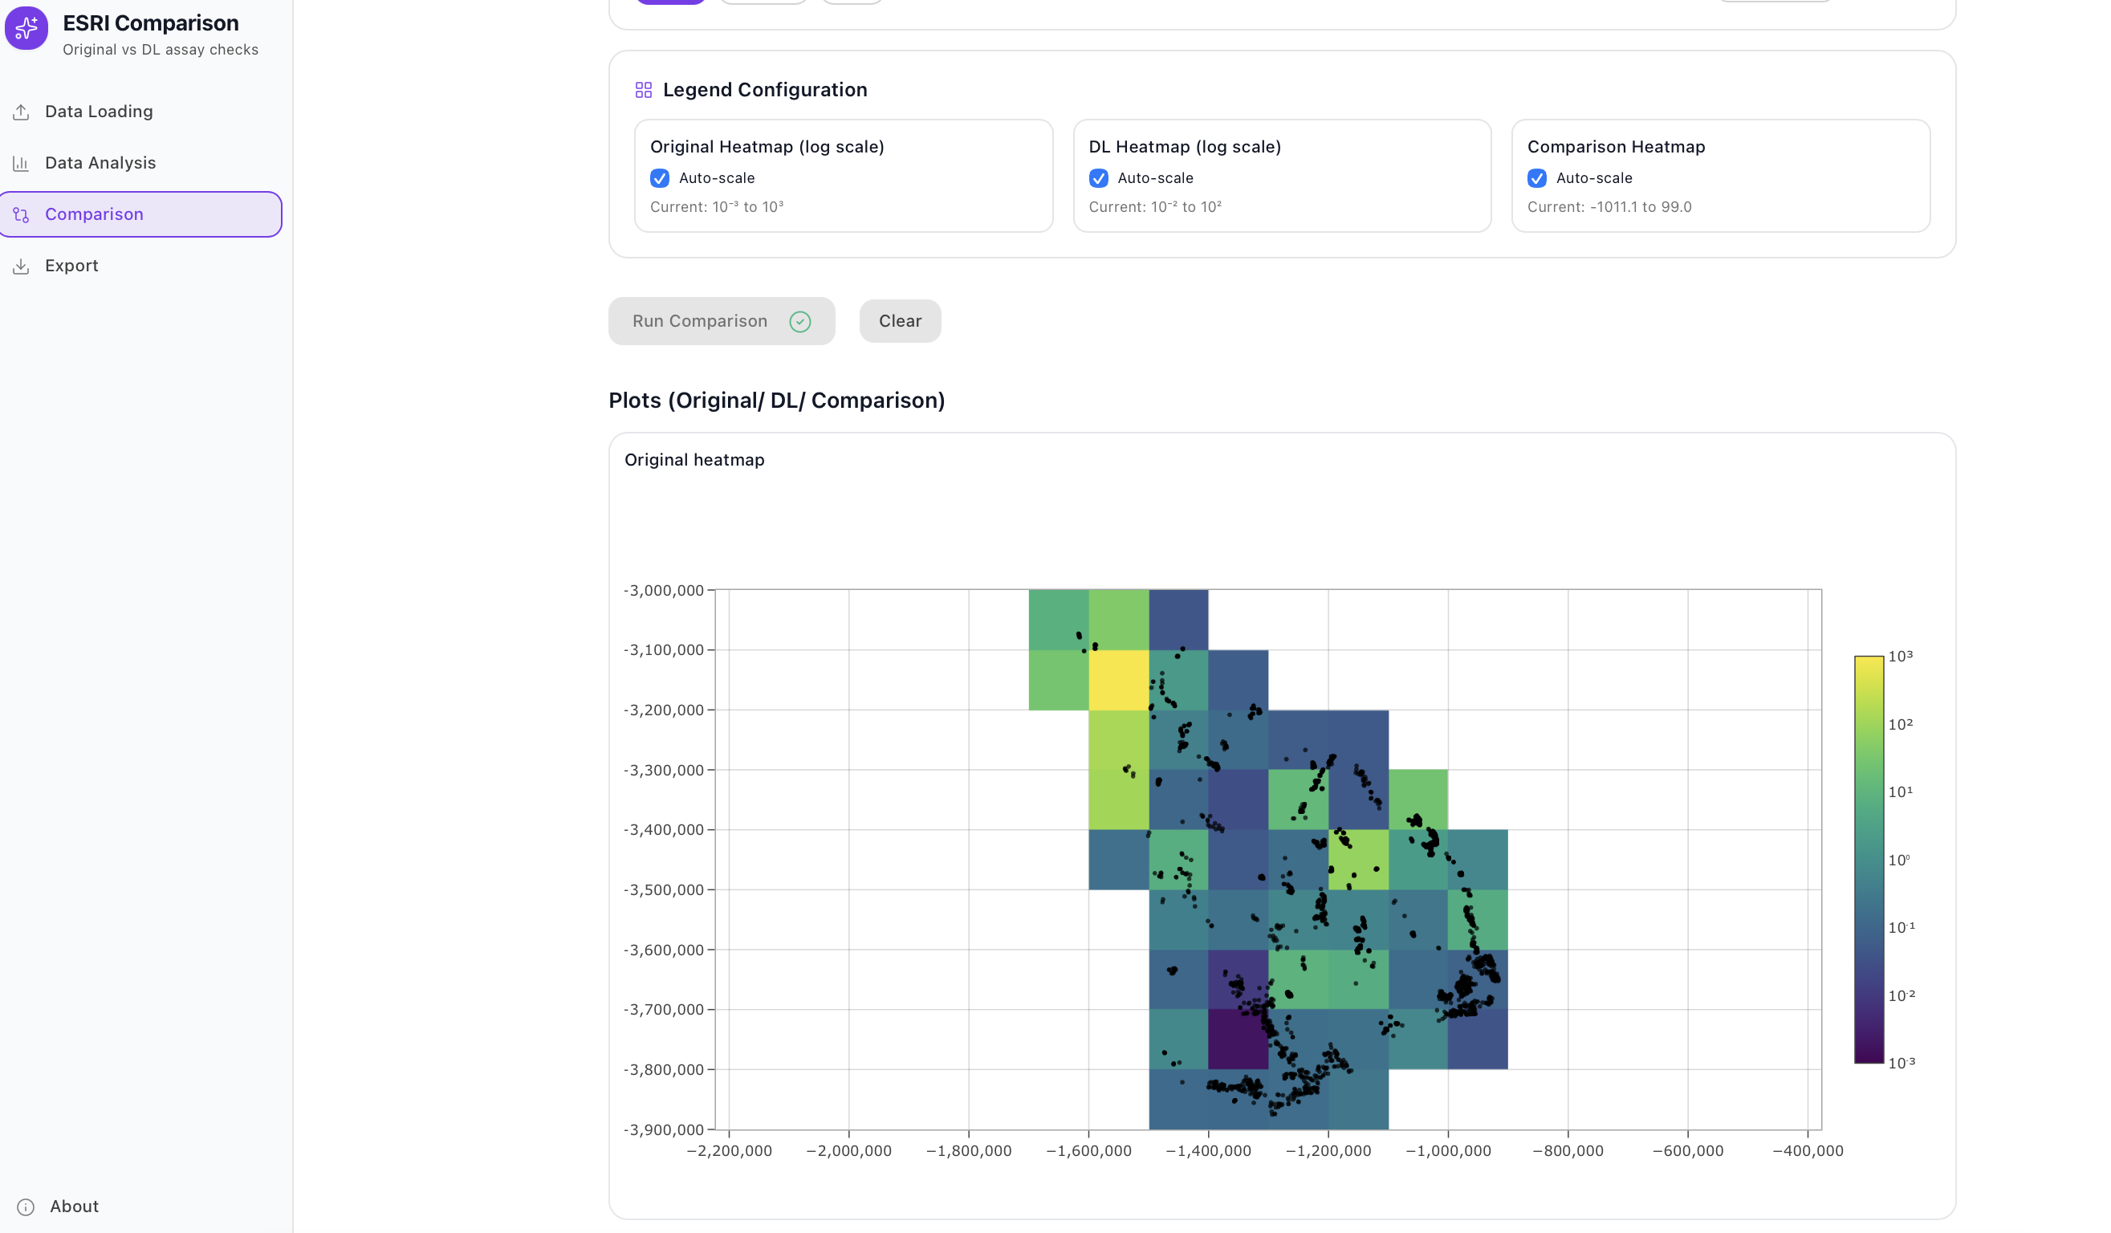
- DL Heatmap - Displays the grid-based distribution of Te_ppm from the DL dataset, aligned to the same scale.
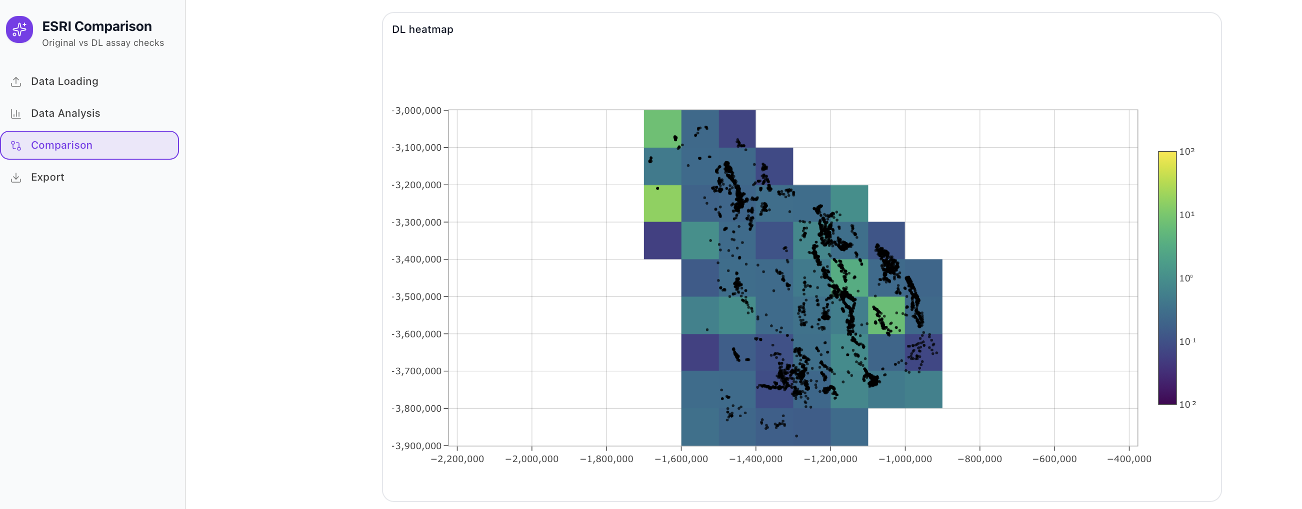
- Comparison Heatmap - Highlights the difference between DL and Original values:
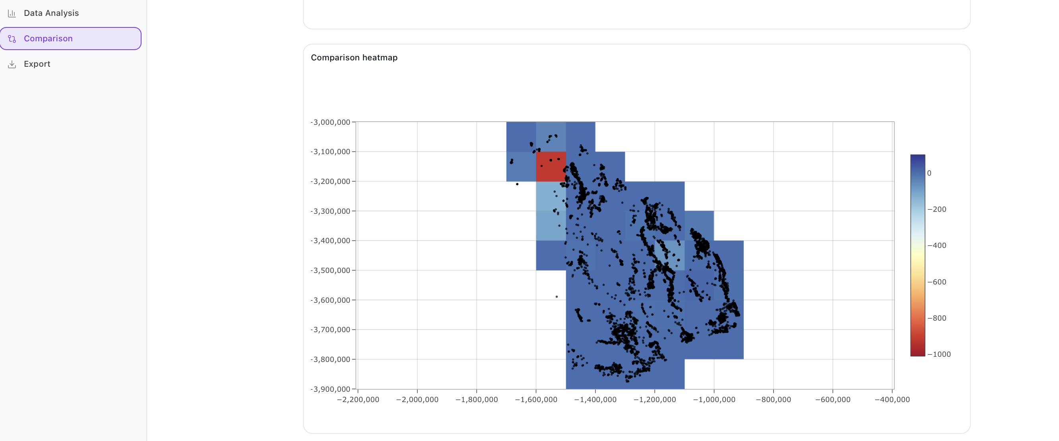
  - Red zones indicate where DL values are higher than Original.
  - Blue zones indicate where DL values are lower than Original.
These three heatmaps allow a quick and intuitive comparison of spatial patterns between the datasets.
Adjust the Legend Configuration
After the heatmaps are generated, use the Legend Configuration section to fine-tune the color scales for better clarity and interpretation.

You can modify the legends for all three maps individually:
- Original Heatmap (log scale)
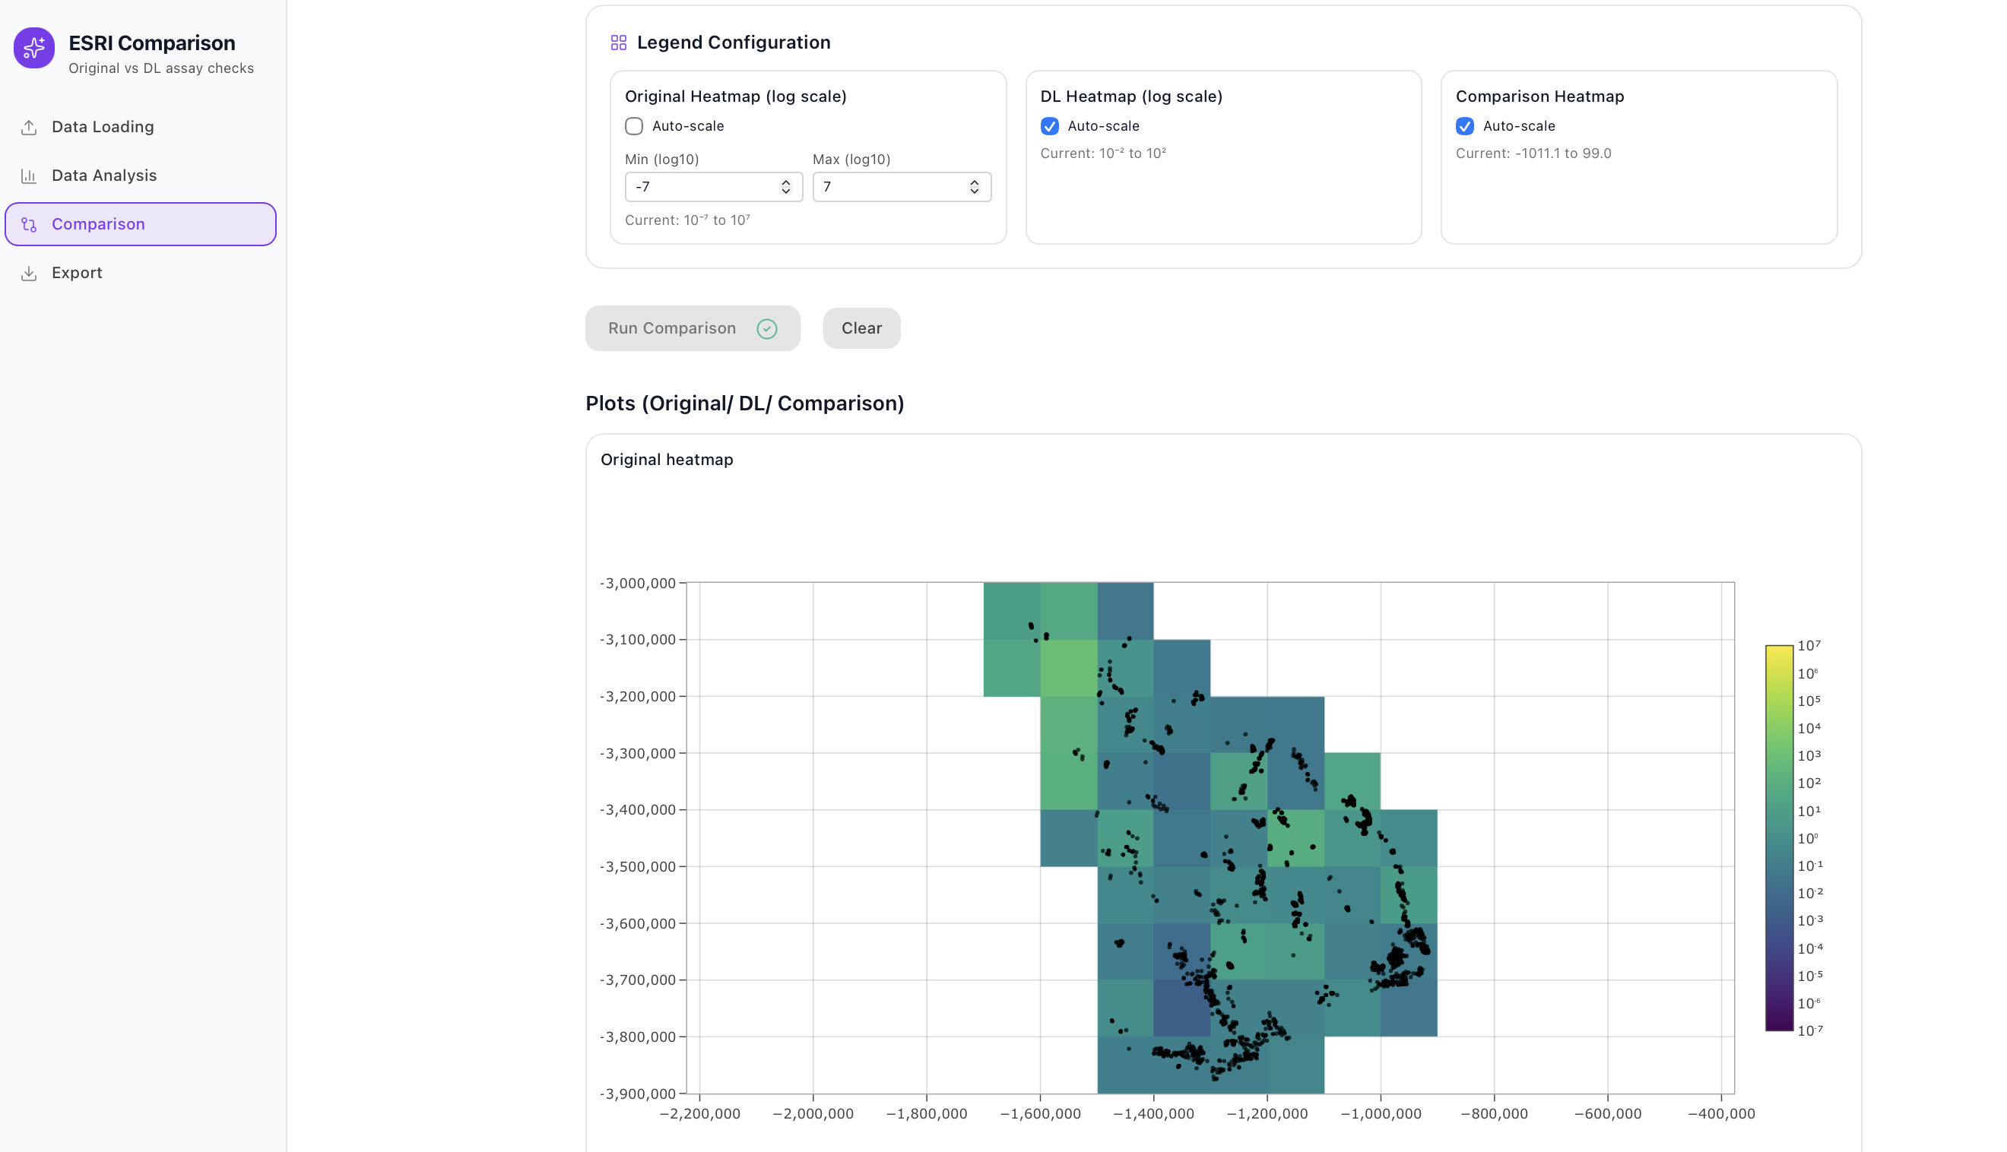
- DL Heatmap (log scale)
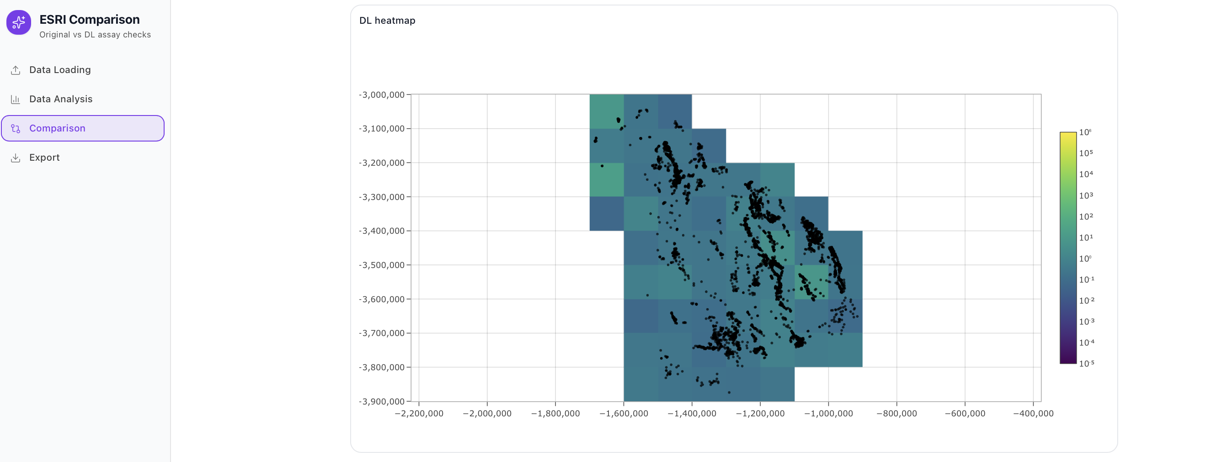

- Comparison Heatmap
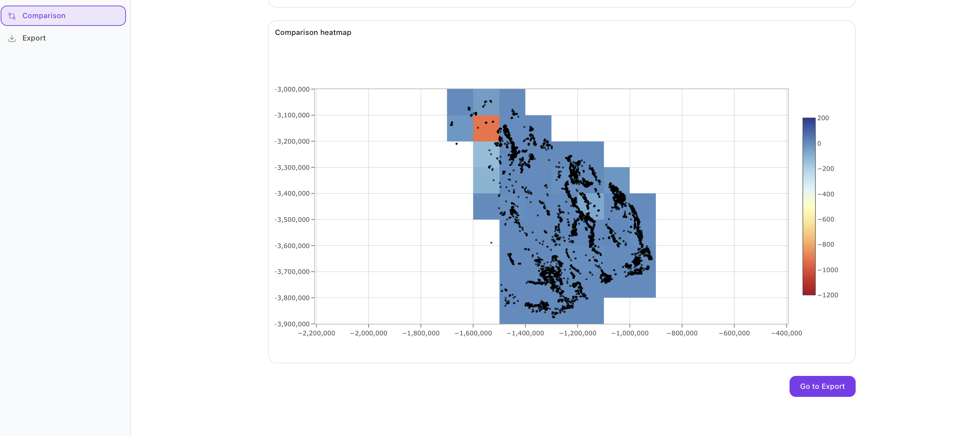
There are two scaling options:
- Auto-scale: Automatically adjusts the minimum and maximum values based on the dataset range.
- Manual Scale: Lets you manually input Min and Max values to highlight specific ranges or focus areas.
Why Log Scale?
Both the Original and DL heatmaps use a logarithmic scale (log scale) because Tellurium (Te_ppm) concentrations in geochemical data often span several orders of magnitude - from very small trace values to extremely high outliers.
A log scale compresses this wide range, allowing subtle variations in lower concentrations to become visible while preventing very high values from overpowering the map.
This makes spatial trends clearer and helps identify patterns that might otherwise be hidden on a linear scale.
For example:
- Setting the Original Heatmap to display values between 10⁻³ and 10³ highlights both trace and elevated Te_ppm zones effectively.
- The Comparison Heatmap, on the other hand, typically uses a linear scale (e.g., -1000 to 120 Δ Te_ppm) since it represents differences rather than magnitudes.
Adjusting the legend after the maps are generated helps fine-tune color contrast and emphasize regions of interest.
Once you’re satisfied with the color scale, the maps update dynamically to reflect your new legend configuration.

4. Export

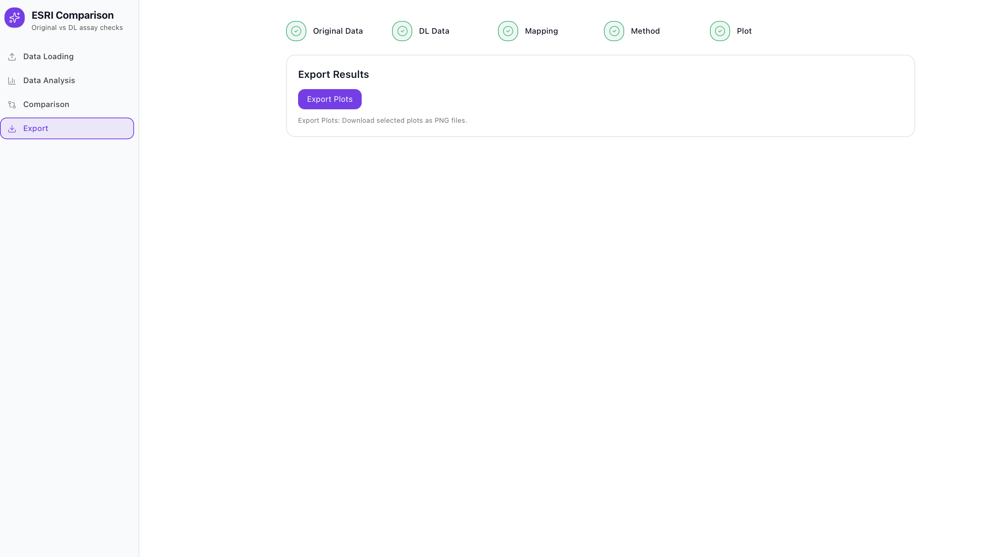
Once you’ve finished running your comparison and reviewing the heatmaps, you can easily save your results for reporting or future analysis.
Head over to the Export tab on the left sidebar.
Export Tab Overview
In this section, you’ll find a simple option - Export Plots.
Clicking it opens a window where you can choose which visualizations to download from your current session.
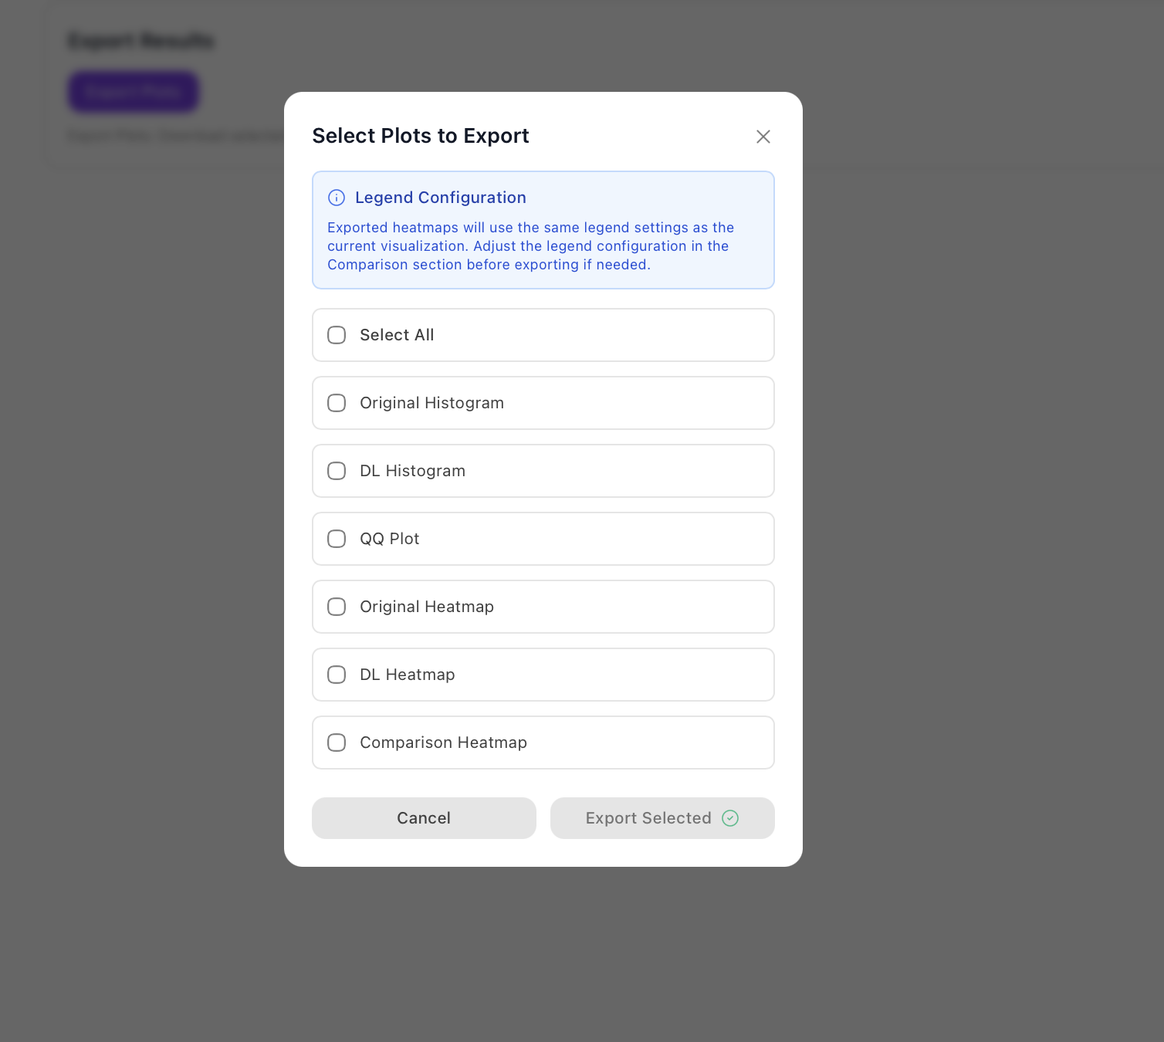
You can export:
- Original Histogram - The distribution of Te_ppm values from your original dataset.
- DL Histogram - The distribution of Te_ppm values from the Deep Learning (DL) dataset.
- QQ Plot - A quantile-quantile comparison between the Original and DL data.
- Original Heatmap - A spatial grid showing Te_ppm concentrations from the original data.
- DL Heatmap - The same grid, but using DL-imputed Te_ppm values.
- Comparison Heatmap - A difference map highlighting where DL and Original values diverge.
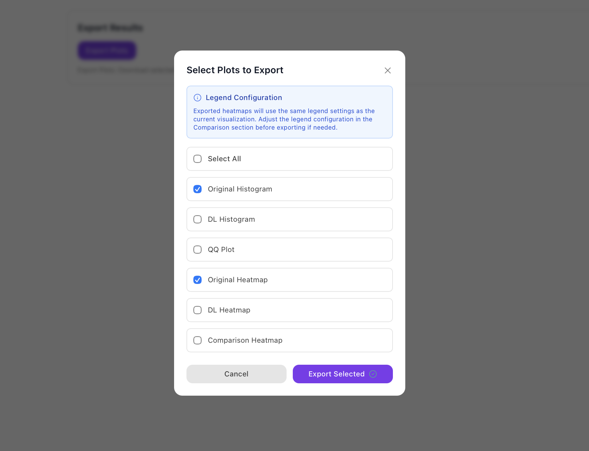
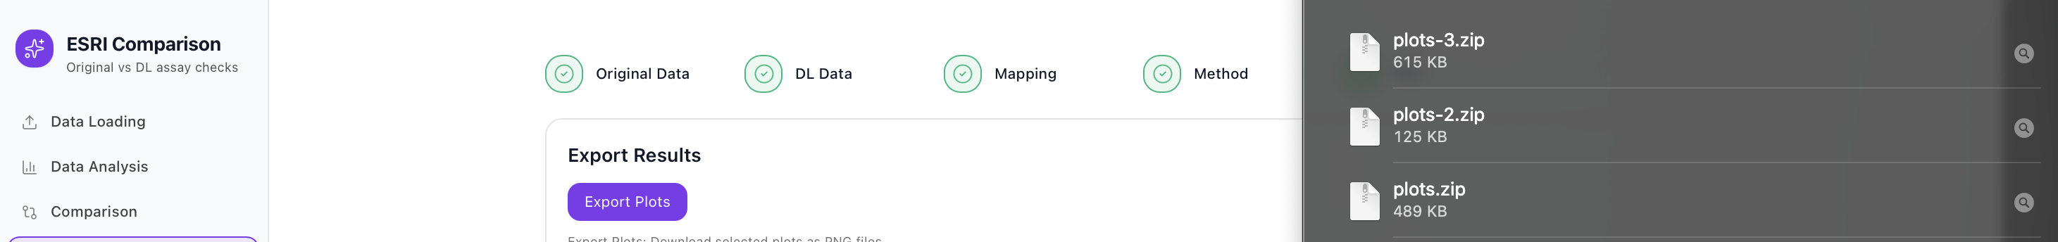
You can tick specific plots or simply select “Select All” if you want to download everything in one go it will be downloaded as a zip file
At the top of the export window, there’s a short reminder: the exported plots will use the same legend and color scale you set in the Comparison tab. If you’d like to change the range or adjust the log scale, just go back to the Comparison section, tweak the legend settings, and then return here to export.
This ensures your saved images match the exact visualization you see on screen.

Exporting the Files
When you’re ready, click Export Selected to download your chosen plots as high-quality PNG images. Each export keeps your axes, color scales, and overlay points - so the visual looks identical to what you viewed inside the tool.
If you change your mind, you can hit Cancel to close the export window without saving anything.
This makes it easy to include the maps and plots directly in reports, presentations, or publications - without needing any extra formatting.

Tips & Troubleshooting
- If your plots look blank, try increasing the grid size (500-1000 m).
- CSV not UTF-8 / bad delimiter → resave as clean UTF-8 CSV.
- If axes look flipped, check you didn’t swap Northing/Easting during mapping.
- If you choose Chi² and see errors, that usually means some cells have too few samples. Try a larger grid size or switch to mean/median/max.
- Always check the histograms and QQ plot before moving to the comparison step it can save time by catching issues early. Do a quick Data Analysis ➜ Show Plots review before running grid comparisons.
- Try multiple grid sizes to see scale-dependent patterns.

Table: Outputs Generated by the ESRI Comparison Tool

Output Type | Description | Format | Purpose / Use Case
Original Histogram | Displays the frequency distribution of Original Te_ppm assay values using a log-scaled x-axis. | PNG | Helps identify the spread, skewness, and data range of the original assay measurements.
DL Histogram | Shows the distribution of DL-predicted or imputed Te_ppm values using the same log scale. | PNG | Allows comparison of variability and magnitude between original and DL datasets.
QQ Plot (Quantile-Quantile) | Plots quantiles of Original vs DL datasets on a log-log scale to assess how closely their distributions align. | PNG | Shows how well DL data statistically follows the distribution of the original dataset.
Original Heatmap | Grid-based spatial map of Te_ppm values (Mean, Median, or Max per grid cell) for the original dataset. | PNG | Highlights the regional pattern of original assay concentrations.
DL Heatmap | Grid-based spatial map of DL-predicted Te_ppm values aligned on the same grid. | PNG | Enables spatial comparison between predicted and original datasets.
Comparison Heatmap | Visual difference map showing DL - Original for each grid cell, using a diverging color scale (red/blue). | PNG | Identifies where DL predictions overestimate or underestimate actual assay values.
Summary Statistics | Count, mean, median, maximum, and standard deviation of Te_ppm values for both datasets. |  | Provides numeric summaries for quick validation and dataset comparison.

